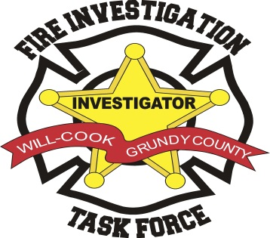

Will - Cook- Grundy County

Founding rganization 2002 - 2012

Fire Investigation Task Force 2013

**Will –Cook Grundy County Fire Investigation Task Force**

**P.O. Box 21 Steger Illinois 60475**

**(708) 755-9589**